**PROPOSAL**

*(Campaign to Showcase Trading Fee Savings and Enhance Customer Engagement)*

1. **Issue**

* Customers lack insight into their trading habits and how they affect their long-term performance
* Customers are unaware of the savings they get from our zero-fee, low-margin policy
* Our product, Pinefolio, has low awareness and adoption among potential users
* Our brand image is weak and does not communicate our competitive advantage of zero-fee, low-margin trading.

1. **Solution**

* We are writing to propose a comprehensive project aimed at solving the above issues. This project aligns with our commitment to customer-centricity and seeks to elevate our brand awareness and customer loyalty.
* We will create a new section in the "customers' profile" (white frame 2) that displays the statistics of their trading habits and portfolio performance. This section will also prompt them to use our Pinefolio service.
* We will emphasize the savings they can get from our competitive policy in this section.
* Since this section is not easily accessible in our app, we will also design a series of report cards that pop up (white frame 1) and show key information about the customers, such as their trading personality, portfolio performance, and savings.
* We will launch a campaign that encourages users to share their "Cards" and spread the word about our competitive policy.
* The primary purpose of this campaign is to underscore the substantial financial benefits our customers receive through zero trading fees. This, in turn, will boost brand awareness and foster stronger customer loyalty.

1. **Campaign Objective**

* **Create competitive advantage:**
  + We will be one of the first securities provide details about customers’ statistics and trading habit
  + We will be one of a few company that provide year-end investment journey report card
* **Increased Brand & policy Awareness:**
  + Highlight the considerable savings to emphasize our customer-centric approach.
  + Enhance brand awareness through targeted marketing campaigns, social media promotions, and PR efforts.
  + Improve product awareness through prompt to action
* **Enhanced Customer Loyalty:**
  + Reinforce the message that we prioritize customers' financial well-being.
  + Strengthen the bond with existing customers, highlighting how Pinetree helps them retain more of their investments.
  + Encourage referrals and positive testimonials, fostering a sense of community and trust.
* **Positive Public Image:**
  + Demonstrate Pinetree's commitment to transparency and fairness in the financial services industry.
  + Garner positive media coverage and industry recognition for our customer-centric practices.

1. **Action steps**
2. **Phase 1: Launch Year End Cards on Dec 31st**

* Calculate all the statistic showing on the card
* Develop a series of cards which show the most attractive characteristics and performance
* Launch a targeted marketing campaign across digital and traditional platforms, encourage customers to share their success stories of savings via Facebook and other SNS, creating a sense of community and trust among potential customers.

1. **Phase 2: Launch Trading Personality & Statistics on Feb 9th 2024 (Lunar New Year)**

* Build models to classify customer trading personalities
* Calculate all the statistics that will be showed in the My Profile Section
* Design & develop the section as an interactive web page
* Embed the web page into our apps: WTS, Alpha, PineX
* Design a new series of cards that match lunar new year theme
* Launch a targeted marketing campaign across digital and traditional platforms on new year eve and new year day, encourage customers to share their success stories of savings via Facebook and other SNS, creating a sense of community and trust among potential customers.

1. **Proposed Feature**
2. **Year End Summary Cards**

|  |  |  |
| --- | --- | --- |
| **No** | **English** | **Vietnamese** |
| **1** | Hello [Customer's Name],  Pinetree Securities would like to express our gratitude for your companionship throughout the period of --- years --- months --- days with us. | Xin chào [Tên khách hàng]!  Yay! Vậy là bạn và Pinetree đã bên nhau [năm] năm [tháng] tháng [ngày] ngày 🤝. Pinetree cám ơn bạn rất nhiều! 😍"  Đề xuất:  XXX ngày bên nhau  Bạn và Pinetree đã ở bên nhau X năm, X tháng, X ngày. Cảm ơn bạn nhiều nhiều! |
| **2** | In the past year, you have achieved placing [Number of Orders] orders.  Wow! Amazing! Your total number of orders placed is greater than XX % investors in Pinetree. | Version 1 dành cho Người đặt nhiều lệnh:  Chiến thần đặt lệnh gọi tên Bạn! Năm 2023, bạn đã đặt [số lượng lệnh] lệnh thành công, nhiều hơn XX % nhà đầu tư tại Pinetree.  Version 2 dành cho người đặt ít lệnh:  Một năm sóng gió, có vẻ bạn đang chọn “đứng ngoài quan sát” với [số lượng lệnh] được khớp thành công. Tăng tốc ở năm 2024 nhé!  Đề xuất:  XXX lệnh  Chiến thần đặt lệnh, |
| **3** | [Stock Ticker] is the name that brings you the most pain/Joy  [Stock Ticker] is the name that guides you into the world of investment. | [Mã chứng khoán] - 3 chữ cái yêu thương của bạn, đã giúp bạn tăng [% sinh lời từ mã CK]% vốn trong năm 2023.  (chữ siêu nhỏ) (Thôi mình tạm không nhắc đến [Mã chứng khoán] nhé! Suỵt!) |
| **4** | "You're a great investor! The amount of money you've earned from stock investments ranks in the top xx% at Pinetree, you know!" | Giỏi như bạn, không sớm thì muộn cũng giàu! Lãi chứng khoán đứng top xx % tại Pinetree đó nha! |
| **5** | "You've been next to the price list for [Number of days], maybe even longer than the time spent with your lover!" | Bạn đã ở bên bảng giá [Số ngày], có khi còn nhiều hơn thời gian ở bên người yêu nữa nha! |
| **6** | We have assisted you in saving [Savings Amount] in trading fees. | Giao dịch 0 phí với Pinetree, bạn đã tiết kiệm được [tùy theo giá trị mà tiết kiệm được gi] |
| **7** | Thank you for placing your trust in Alpha Trading - Pinetree's zero-trading fee service.  Wishing you a successful and prosperous 2024, full of good fortune! | Cám ơn bạn đã tin tưởng sử dụng Pinetree - 0 phí giao dịch trọn đời của Pinetree  Chúc bạn sẽ có một năm 2024 rực rỡ thành công và gặp nhiều điều may mắn ! |

1. **Trading Performance Statistics**

|  |  |  |
| --- | --- | --- |
| **No** | **Group** | **Attributes** |
| **1** | Demographics | Customer's lifetime |
| **2** | Activities | Count of trading days |
| **3** | Activities | Total trading orders |
| **4** | Activities | Total trading orders by months |
| **5** | Activities | Rank of trading orders |
| **6** | Activities | Total trading values |
| **7** | Activities | Total trading values by months |
| **8** | Activities | Rank of trading values |
| **9** | Performance | Total money deposit |
| **10** | Performance | Total money withdraw |
| **11** | Performance | Average NAV |
| **12** | Performance | NAV on begin date |
| **13** | Performance | NAV on end date |
| **14** | Performance | Capital turnover ratio |
| **15** | Performance | Average RTT |
| **16** | Performance | Average holding period |
| **17** | Performance | Portfolio PnL return by date |
| **18** | Performance | Portfolio PnL |
| **19** | Performance | Holding period return (HPR) |
| **20** | Performance | Rank of HPR |
| **21** | Performance | Pinefolio PnL return by date |
| **22** | Performance | VNIndex return by date |
| **23** | Performance | Portfolio volatility |
| **24** | Performance | Best performing trading symbol |
| **25** | Performance | Worst performing trading symbol |
| **26** | Cost savings | Trading fee |
| **27** | Cost savings | Broker fee |
| **28** | Cost savings | Tax fee |
| **29** | Cost savings | Service fee |
| **30** | Cost savings | Savings fee |
| **31** | Cost savings | Margin interest |
| **32** | Cost savings | Cash Advanced interest |
| **33** | Cost savings | Savings loan interest |
| **34** | Portfolio allocation | Product allocation |
| **35** | Portfolio allocation | Sector allocation |
| **36** | Portfolio allocation | Asset allocation |

1. **Propose Marketing tactic(s)**

* Minigame on Facebook: share to get gift from Pinetree
* Notification/ pop up on app
* Story/ post on facebook & zalo

1. **Anticipated resources:**

|  |  |  |  |
| --- | --- | --- | --- |
| **No.** | **Task** | **PIC** | **Completed By** |
| **1** | Classify customer trading personalities | DA | 08/12/23 |
| **2** | Calculate all the statistics that will be showed in the My Profile Section | DA | 22/11/2023 |
| **3** | Create the content of the cards | Marketing & DX | 30/11/2023 |
| **4** | Design interactive web page for Trade Personality report function (draft to DA) | WTS | 08/12/2023 |
| **5** | Create UI design for the feature for cards | DX | 08/12/2023 |
| **6** | Develop the cards feature in the app(s) | DP | 27/12/2023 |
| **7** | Execute advertising for the feature and gift-giving program for customers who share the program's post on SNS. | Mkt | 31/12/2023 |
| **8** | **Launch Date Phase 1** | **DP** | **31/12/2023** |
| **9** | Confirm if it’s possible to do Webview | WTS | 29/12/2023 |
| **10** | Naming & Design & Write small description for characteristic | Mkt | 20/1/2024 |
| **11** | Create UI “Tet” theme design for cards | DP | 5/1/2024 |
| **12** | Develop Customer Statistic page | WTS/DP | 26/1/2024 |
| **13** | Update the final statistic & personality | DA | 07/02/2024 |
| **14** | Prepare mkt campaigns & notification for launch date during holiday | MKT | 07/02/2024 |
| **15** | **Launch Date Phase 2** | **DP, MKT** | **09/02/2022** |

Wireframe for Card  
  
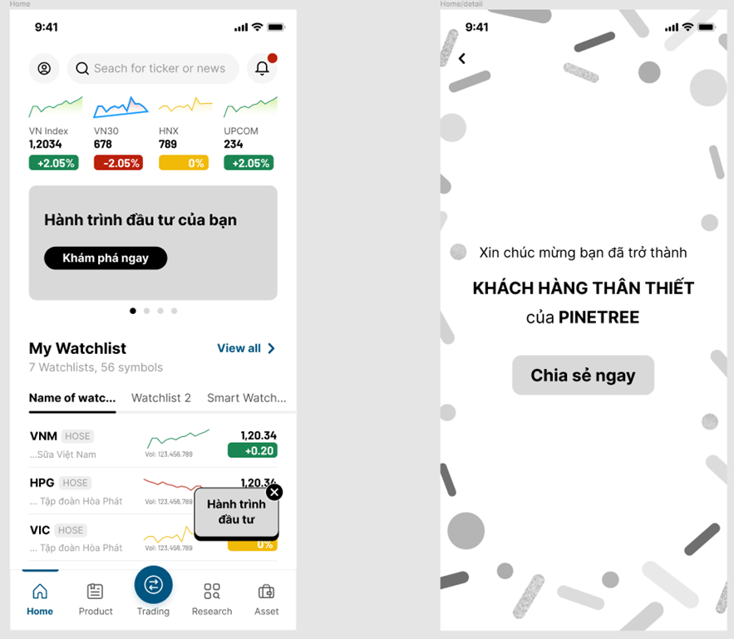

Wireframe for Statistic Report:

